1 ques: greedy approach of huffman code
#include <stdio.h>
#include <stdlib.h>
struct Node {
char data;
unsigned freq;
struct Node *left, *right;
};
struct MinHeap {
unsigned size;
unsigned capacity;
struct Node** array;
};
struct Node* newNode(char data, unsigned freq) {
struct Node* temp = (struct Node*) malloc(sizeof(struct Node));
temp->left = temp->right = NULL;
temp->data = data;
temp->freq = freq;
return temp;
}
struct MinHeap* createMinHeap(unsigned capacity) {
struct MinHeap* minHeap = (struct MinHeap*) malloc(sizeof(struct MinHeap));
minHeap->size = 0;
minHeap->capacity = capacity;
minHeap->array = (struct Node**) malloc(minHeap->capacity * sizeof(struct Node*));
return minHeap;
}
void swapNode(struct Node** a, struct Node** b) {
struct Node* t = *a;
*a = *b;
*b = t;
}
void minHeapify(struct MinHeap* minHeap, int idx) {
int smallest = idx;
int left = 2 * idx + 1;
int right = 2 * idx + 2;
if (left < minHeap->size && minHeap->array[left]->freq < minHeap->array[smallest]->freq)
smallest = left;
if (right < minHeap->size && minHeap->array[right]->freq < minHeap->array[smallest]->freq)
smallest = right;
if (smallest != idx) {
swapNode(&minHeap->array[smallest], &minHeap->array[idx]);
minHeapify(minHeap, smallest);
}
}
struct Node* extractMin(struct MinHeap* minHeap) {
struct Node* temp = minHeap->array[0];
minHeap->array[0] = minHeap->array[minHeap->size - 1];
--minHeap->size;
minHeapify(minHeap, 0);
return temp;
}
void insertMinHeap(struct MinHeap* minHeap, struct Node* node) {
++minHeap->size;
int i = minHeap->size - 1;
while (i && node->freq < minHeap->array[(i - 1) / 2]->freq) {
minHeap->array[i] = minHeap->array[(i - 1) / 2];
i = (i - 1) / 2;
}
minHeap->array[i] = node;
}
void buildMinHeap(struct MinHeap* minHeap) {
int n = minHeap->size - 1;
int i;
for (i = (n - 1) / 2; i >= 0; i--)
minHeapify(minHeap, i);
}
void printCodes(struct Node* root, int arr[], int top) {
if (root->left) {
arr[top] = 0;
printCodes(root->left, arr, top + 1);
}

if (root->right) {
arr[top] = 1;
printCodes(root->right, arr, top + 1);
}

if (!root->left && !root->right) {
printf("%c: ", root->data);
for (int i = 0; i < top; ++i)
printf("%d", arr[i]);
printf("\n");
}
}
struct Node* buildHuffmanTree(char data[], int freq[], int size) {
struct Node *left, *right, *top;
struct MinHeap* minHeap = createMinHeap(size);

for (int i = 0; i < size; ++i)
minHeap->array[i] = newNode(data[i], freq[i]);
minHeap->size = size;
buildMinHeap(minHeap);

while (minHeap->size != 1) {
left = extractMin(minHeap);
right = extractMin(minHeap);

top = newNode('$', left->freq + right->freq);
top->left = left;
top->right = right;

insertMinHeap(minHeap, top);
}
return extractMin(minHeap);
}

int main() {
int n;
printf(" number of characters: ");
scanf("%d", &n);

char arr[n];
int freq[n];

printf(" characters:\n");
for (int i = 0; i < n; i++)
scanf(" %c", &arr[i]);
printf(" frequencies:\n");
for (int i = 0; i < n; i++)
scanf("%d", &freq[i]);
struct Node* root = buildHuffmanTree(arr, freq, n);
int codes[100], top = 0;
printf("\nHuffman Codes are:\n");
printCodes(root, codes, top);

return 0;
}
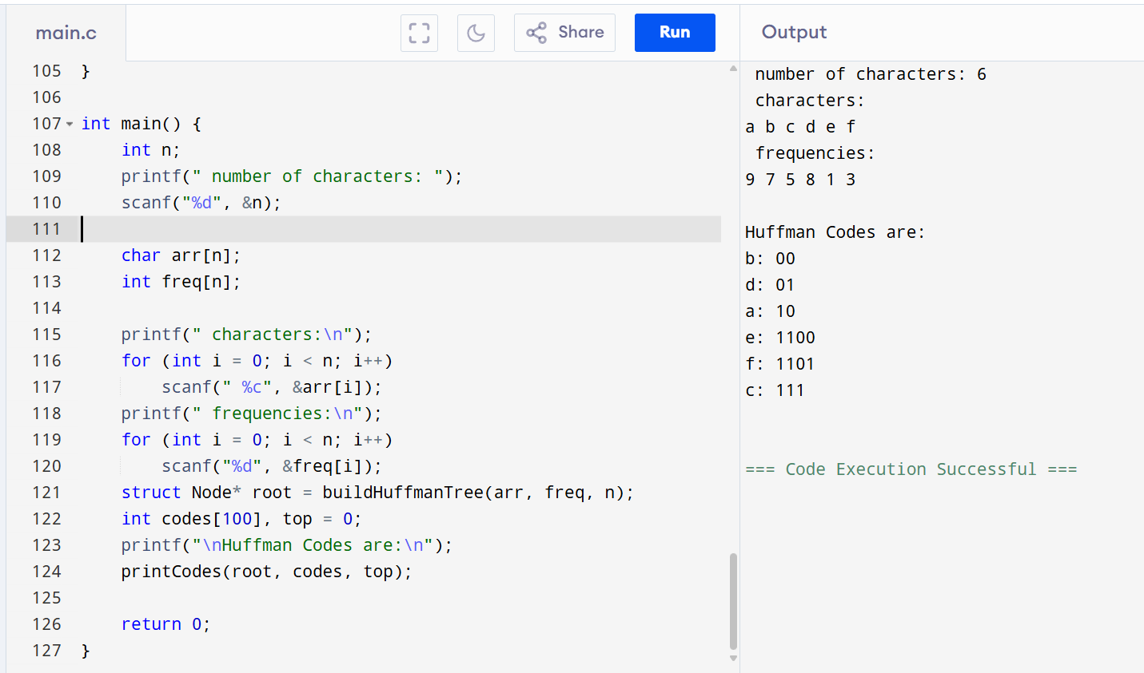
2 QUES : GIVEN a: 20, c:11, d:2, e: 10, o:15, m:8, s:10, t:22, u: 2
